**DHCP CONFIGURATION**

DHCP stands for dynamic host configuration protocol and is a network protocol used on IP networks where a DHCP server automatically assigns an IP address and other information to each host on the network so they can communicate efficiently with other endpoints.

In addition to the IP address, DHCP also assigns the subnet mask, default gateway address, domain name server (DNS) address and other pertinent configuration parameters.

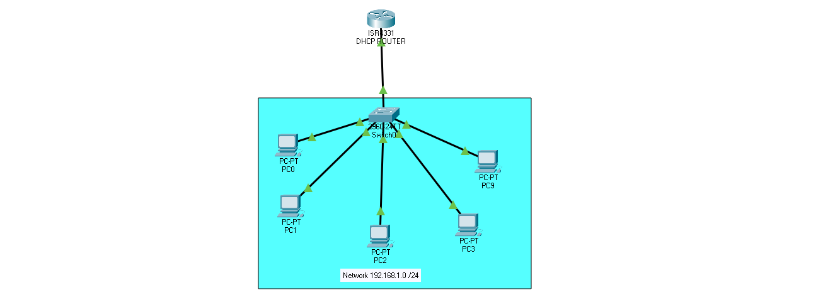

**Router Configuration Commands**

Router > enable

Router # config terminal

Router (config) # interface GigabitEthernet0/0/0

Router (config-if) # ip address 192.168.1.1 255.255.255.0

Router (config-if) # no shutdown

Router (config-if) # exit

Router (config) # ip dhcp pool LOCAL

Router (dhcp-config) # network 192.168.1.0 255.255.255.0

Router (dhcp-config) # default-router 192.168.1.1

Router (dhcp-config) # dns-server 192.168.1.4

Router (dhcp-config) #netbios-name-server 192.168.1.7

Router (dhcp-config) # domain-name example.com

Router (dhcp-config) # exit

Router (config) # ip dhcp excluded-address 192.168.1.1 192.168.1.10

Router (config) # service dhcp